***CENTRIFUGAL FORCE***

The word centrifugal is derived from the Latin terms ‘**Centrum**’ and ‘**fugere**’ meaning to flee or tending to **move away** from the centre, this term was used by **Sir Isaac Newton** back in **1629**.

Centrifugal force is a **virtual** (pseudo) force because there is no real force causing it like Gravitational, Electrical, and Magnetic forces. A virtual force can be defined as any system of forces in **equilibrium**.

Centrifugal force describes the tendency of an object following a **curved path** to fly outwards **away** from the centre.

Let us consider an example,

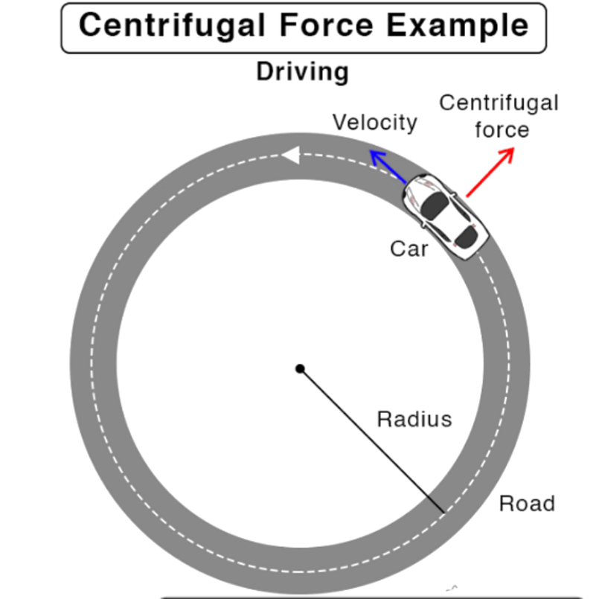

Credits for the pic : **Sciencefacts.net**

In this scenario the driver will experience an outward push from the centre because of the **Inertia of direction**, the force that pushes him outwards is Centrifugal force.

In this case, **Frictional force** acts as the Centripetal force.

The Centrifugal force is always directed **away** from the centre of the circle.

Centrifugal force can be defined as the **apparent outward force** acting on a mass when it is **rotated.**

The formula for Centrifugal force is,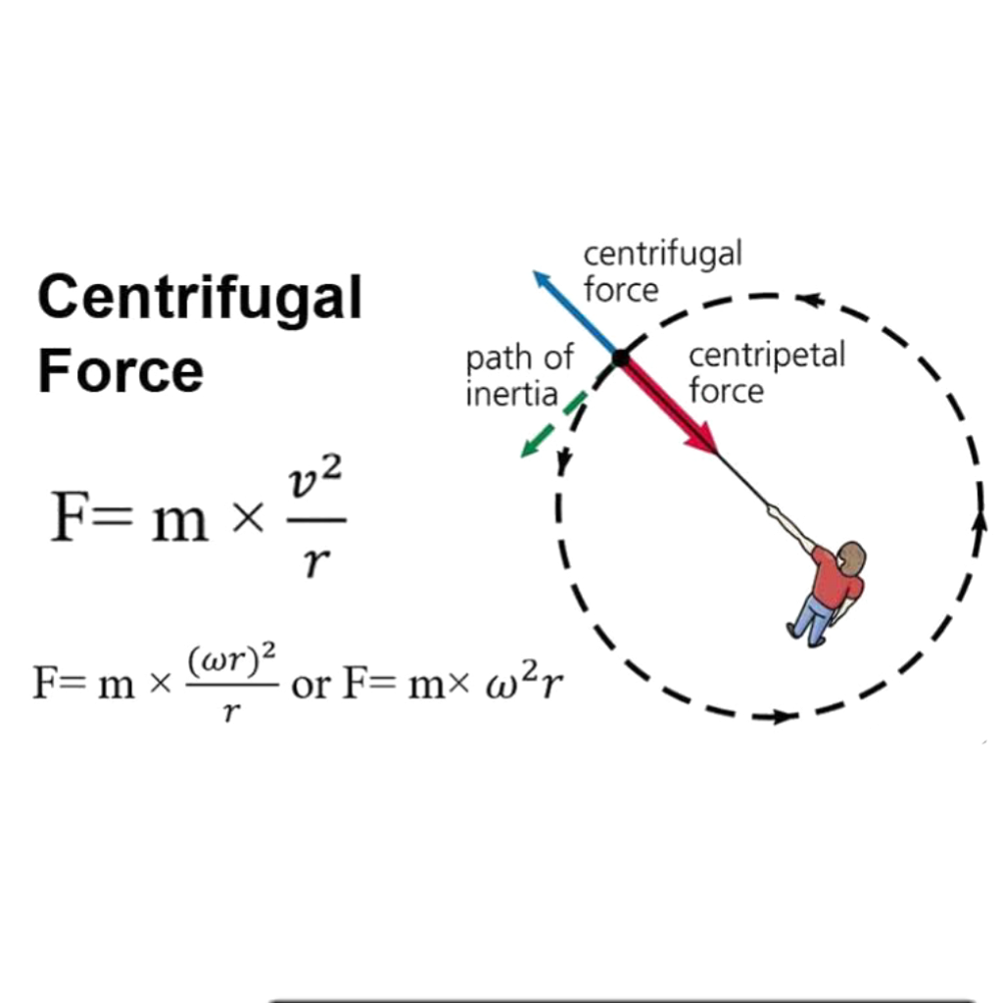

Credits for the pic: **Precision Graphics**

[As, v=ꙍ*r]

Here, omega = Angular Displacement of the mass.

R is the distance of that mass from the centre

The unit for Centrifugal force is same as that of Centripetal: **Newton**.

***THANK YOU***